College and University
Fact Sheets
Table of Contents:

p. 2 Arkansas State University

p. 3 Harvard University

p. 4 Hendrix

p. 5 Massachusetts Institute of Technology (MIT)

p. 6 Mississippi State University

p. 7 Princeton University

p. 8 Savannah College of Art & Design (SCAD)

p. 9 Spelman College

p. 10 United States Air Force Academy

p. 11 University of Missouri, Columbia

p. 12 University of Texas, Austin

p. 13 Yale

The information about the colleges and universities in this packet was current as of January 6, 2017. Resource: www.bigfuture.collegeboard.org

Location: State University, AR

Public/Private: Public

Tuition (including room and board): $17,750

Financial Aid: the average financial aid package is $10,000

Number of Undergraduate Students: 9,592

Student to faculty ratio: 17 to 1

Cost of living (in addition to tuition): $4,913

Student Population:
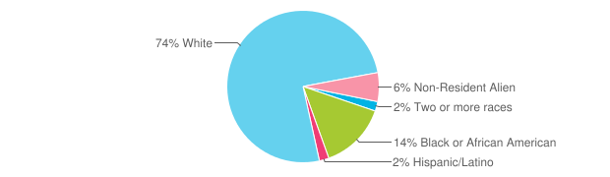

Somewhat selective - 70% of applicants are admitted

GPA of Incoming Freshmen: 86% entered with a GPA of 3.0 or higher.

Location: Cambridge, MA

Public/Private: Private

Tuition(including room and board): $64,025

Financial Aid: average financial aid package is $50,402

Number of Undergraduate Students: 6,699

Student to faculty ratio: 7 to 1

Cost of living (in addition to tuition): $8,375

Student Population:
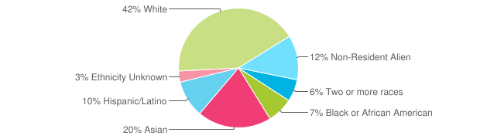

Most Selective: 6% of applicants admitted

GPA of Incoming Freshmen: 90% entered with a 3.75 GPA or higher

Location: Conway, AR

Public/Private: Private

Tuition (including room and board): $55,120

Financial Aid: Average 1st year financial aid package was $36,488.

Number of Undergraduate Students: 1,327

Student to faculty ratio: 11 to 1

Cost of living (in addition to tuition): $3,000

Student Population:
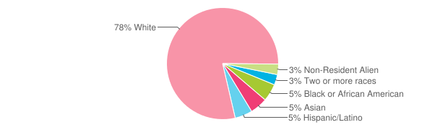

Less Selective: 82% of applicants admitted

GPA of Incoming Freshmen: 90% entered with a GPA of 3.25 or higher.
Location: Cambridge, MA

Public/Private: Private

Tuition (including room and board): $63,662

Financial Aid: Average 1st year financial aid package was $42,175

Number of Undergraduate Students: 4,527

Student to faculty ratio: 3 to 1

Cost of living (in addition to tuition): $3,632

Student Population:

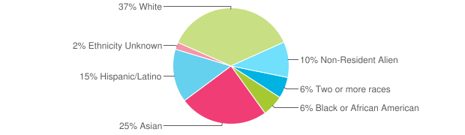

Most Selective: 8% of applicants accepted

Incoming Freshmen: 100% were ranked in the top 25% of their graduating class.
Location: Mississippi State, MS

Public/Private: Public

Tuition (including room and board): $18,550

Financial Aid: Average 1st year financial aid package was $16,333

Number of Undergraduate Students: 17,421

Student to faculty ratio: 19 to 1

Cost of living (in addition to tuition): $5,154

Student Population:
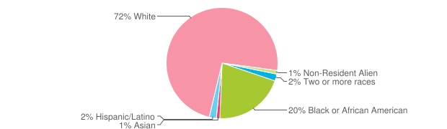

Somewhat selective: 72% of applicants admitted

GPA of incoming Freshmen: 60% entered with a GPA of 3.25 or higher.

Location: Princeton, NJ

Public/Private: Private

Tuition (including room and board): $61,140

Financial Aid: The average financial aid package is $45,467.

Number of Undergraduate Students: 5,402

Student to faculty ratio: 5 to 1

Cost of living (in addition to tuition): $3,250

Student Population:

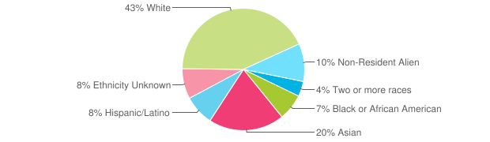

Most selective: 7% of applicants admitted
GPA of Incoming Freshmen: 88% entered with a GPA of 3.75 or higher.
Location: Savannah, GA
Atlanta, GA
Hong Kong, China
Lacoste, France
*Students can choose to study in any location, at any quarter during their education – with no change in tuition cost.

Public/Private: Private

Tuition (including room and board): $49,494

Financial Aid: The average financial aid package is $17,254

Number of Undergraduate Students: 10,186

Student to faculty ratio: 19 to 1

Cost of living (in addition to tuition): depends on location

Student Population:
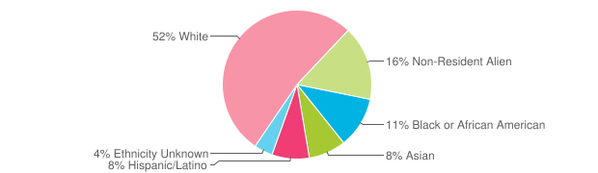

Somewhat selective: 69% of applicants are accepted
GPA of Incoming Freshmen: 84% entered with a GPA of 3.0 or higher

Location: Atlanta, GA

Public/Private: Private (women only)

Tuition (including room and board): $42,109

Financial Aid: The average financial aid package is $13,602

Number of Undergraduate Students: 2,144

Student to faculty ratio: 10 to 1

Cost of living (in addition to tuition): $4,300

Student Population:

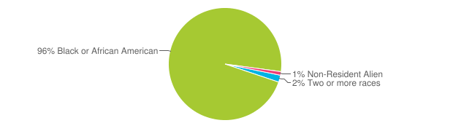

Very Selective: 48% of applicants admitted

GPA of Incoming Freshmen: 62% entered with a GPA of 3.50 or higher.

Location: USAF Academy, CO

Public/Private: Public

Tuition (including room and board): $0 (All cadet expenses, including tuition, room and board and supplies are paid for by the federal government)

Number of Undergraduate Students: 4,111

Student to faculty ratio: 8 to 1

Student Population:
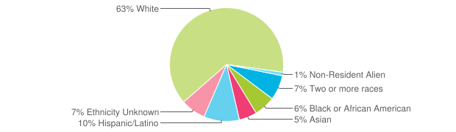
Most selective: 17% of applicants accepted
Requirements:
- Must be a citizen of the United States
- Unmarried with no dependents
- Between the ages of 17 and not past the 23rd birthday on July 1 of the year of entry
- Good moral character
- Legal nomination from member of Congress, US President or Vice President or other selected sources required
- Secondary school record, test scores, leadership ability, extracurricular activities and character are most important.
- Satisfactory completion of medical exam and fitness test
- Personal interview
Location: Lexington, KY

Public/Private: Public

Tuition (including room and board): $21,550

Financial Aid: The average financial aid package is $11,867

Number of Undergraduate Students: 22,223

Student to faculty ratio: no information provided

Cost of living (in addition to tuition): $3,260

Student Population:
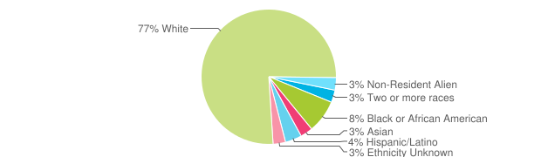

(admission statistics not provided by the university)
GPA of Incoming Freshmen: 62% entered with a GPA of 3.50 or higher.
Location: Columbia, MO

Public/Private: Public

Tuition (including room and board): $20,618

Financial Aid: The average financial aid package is $14,987

Number of Undergraduate Students: 27,812

Student to faculty ratio: information not provided

Cost of living (in addition to tuition): $2,700

Student Population:
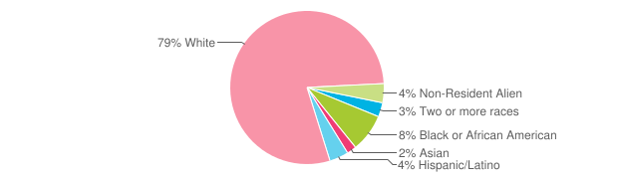

Less Selective: 78% of applicants admitted

Incoming Freshmen: 87% were ranked in the top half of their graduating class.

Location: Austin, TX

Public/Private: Public

Tuition (including room and board): $22,228

Financial Aid: The average financial aid package is $11,685

Number of Undergraduate Students: 39,619

Student to faculty ratio: 18 to 1

Cost of living (in addition to tuition): $4,310

Student Population:
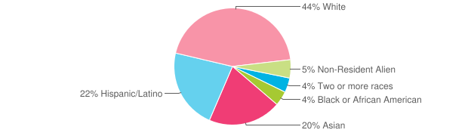

Very Selective: 39% of applicants admitted
Incoming Freshmen: 98% were ranked in the top half of their graduating class.

Location: New Haven, CT

Public/Private: Private

Tuition (including room and board): $68,230

Financial Aid: The average financial aid package is $52,016

Number of Undergraduate Students: 5,532

Student to faculty ratio: 6 to 1

Cost of living (in addition to tuition): $3,000

Student Population:

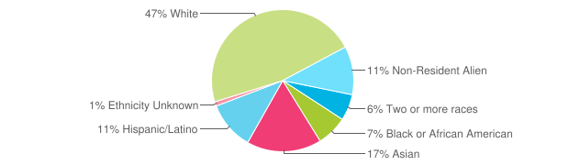

Most selective: 7% of applicants accepted

Incoming Freshmen: 97% were ranked in the top 10% of their graduating classes.

